ROBOTIC ARM WITH MACHINE LEARNING CAPABILITIES

AIM :

Our goal is to create an robotic arm that identifies and takes the specified object to the user.

WORKING :

1. First the RAMLC learns the object with the help of user by showing it to the camera.

2. Then the RAMLC saves the users face who gave request to find the object

3. RAMLC searchs the room for the object

4. RAMLC picks the object and takes it back to user who gave the request

If there are same objects in multiple color and shape, the robot picks the exact same object shown by the requested user. The user has to the recoginition process only once , the face and object will be saved in its memory for future reference.

The RAMLC only picks the object within its vision, so there wont be any advanced searching method (as it its not already).

The size of the RAMLC is not confirmed as it will be according to our budget.

MODEL :

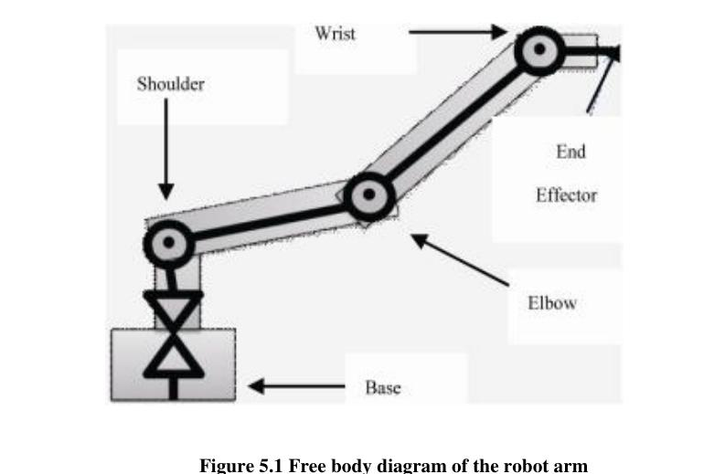

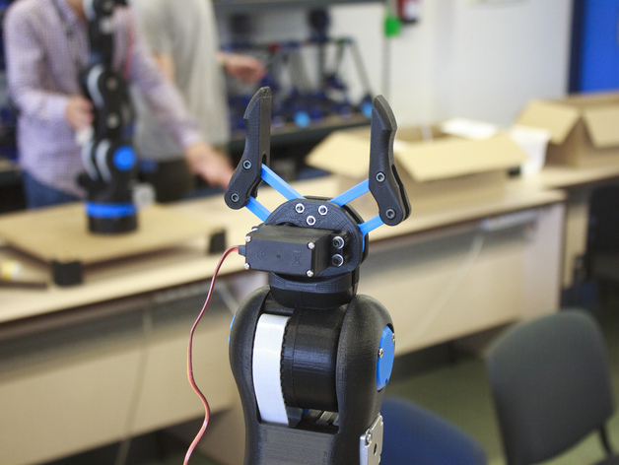

(Model is not finalised yet)

PLAN OF EXCECUTION:

1. PHASE 1:

In phase 1, we will implement the hardware of the RAMLC using Rasberry Pi (a mini computer). At this phase RAMLC can be controlled by a remote controller or smart phone. As it is a microcontroller based device later on we can change the source code to update it to a intelligent machine

2. PHASE 2:

Givings the brawns a brain, In this phase, 1 or 2 cameras are connected to the Rasberry Pi for sensing the enviroment(ultrasonic sensors will also be connected). Then the source code will be altered to give the RAMLC the ability to identify faces and objects to its surroundings

PARTS OR TECHNOLOGIES :

1.RASBERRY PI:

The Raspberry Pi is a low cost, credit-card sized computer that plugs into a computer monitor or TV, and uses a standard keyboard and mouse. It is a capable little device that enables people of all ages to explore computing, and to learn how to program in languages like Scratch and Python. It’s capable of doing everything you’d expect a desktop computer to do, from browsing the internet and playing high-definition video, to making spreadsheets, word-processing, and playing games.
Here the Rasberry Pi is used as the brain of the RAMLC. As it is a mini pocket sized computer it is very much hackable and its specifications are very much suited for the task.

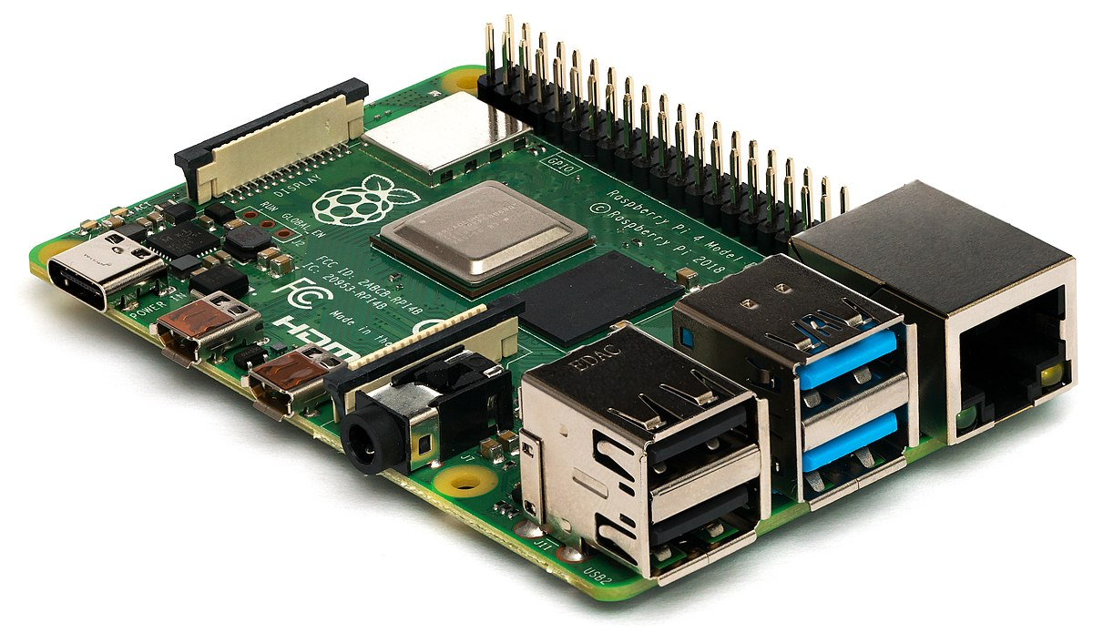

2. SERVO MOTORS :

A servomotor is a linear actuator or rotary actuator that allows for precise control of linear or angular position, acceleration, and velocity. It consists of a motor coupled to a sensor for position feedback. It also requires a relatively sophisticated controller, often a dedicated module designed specifically for use with servomotors.

Here the sevo is used to precisley control the parts of the and give the arm a 6axis motion

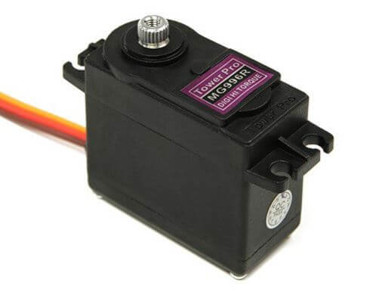

3. ULTRASONIC SENSOR :

An ultrasonic sensor is an electronic device that measures the distance of a target object by emitting ultrasonic sound waves, and converts the reflected sound into an electrical signal. Here it is used to detect objects infront of RAMLC

4. RASBERRY PI CAMERA MODULE :

Rasberry pi camera module is used to give a visual input to the rasberry pi.

